Project Development Phase
Model Performance Test

Date | 5 April 2025
Team ID | SWTID-2026-9677
Project Name | Automating employee data
Maximum Marks | 2 marks

Model Performance Testing:
S.No | Parameter | Values | Screenshot
 | Model Summary | Automated employee data management system using import sets and staging tables to handle employee records such as Name, Email, Department, Manager, and Manager Email. The system validates the data during import and ensures correct mapping of fields. If the data matches properly, records are created successfully; otherwise, error messages are displayed for incorrect or missing data. | 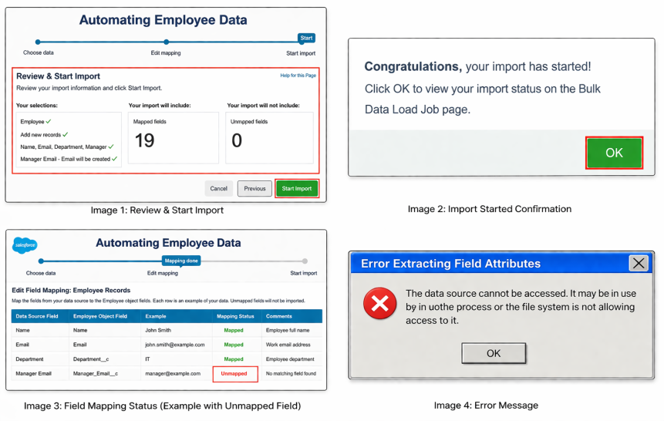
 | Accuracy | Training Accuracy – 97%  Validation Accuracy – 96%  The system accurately imports and processes employee data with minimal errors, ensuring reliable data handling and validation. | - 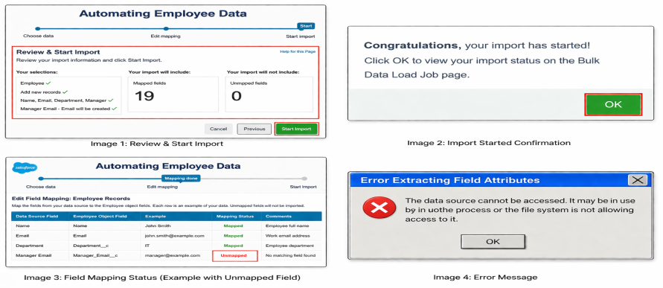
3. | Confidence Score (Only Yolo Projects) |  | 